Functional Specifications Document (FSD)
  - (Name of Project)
  - (Date: mm/dd/yy)
  - Version X.XX

  - Document Revisions
Date | Version Number | Nature of changes
05/02/2020 | 0.1 | Initial Draft

  - Approvals
Name | Role | Signature | Date
 | Project Sponsor
 | Customer PM
 | Project Manager
 | System Architect
 | Development Lead
 | User Experience Lead
 | Quality Lead
 | Content Lead

Introduction

Project Summary

Business Need/Problem
[This section should describe the business problem/need faced by the organization]

Product Vision
[These should describe the product vision in developing the product]

Potential Value/Benefits
[Provide a brief listing of expected benefits from implementing the project/developing the product. These can be monetary or non- monetary]

Project Scope
[This section describes what work is in scope for the project, and what work is out of scope… that is beyond the current budget, resources and timeline as approved by the project stakeholders. This is designed to prevent “scope creep” of additional features and functions not originally anticipated. You can further divide the sections” In scope” as Release 1, Release 2 and indicate what is within the scope of a particular release]

In Scope Functionality

Out of Scope Functionality

Assumptions

Constraints

Functional Requirements
[The functional requirements elicited from stakeholders are to be documented in the below sections. You can replicate sections 2.1 depending upon the number of requirements you have in your project. A sample functional requirement has been added in section 2.1]

Book a Flight
When the User clicks on Book Flight link, the Flight booking screen is displayed. On this screen, user shall enter all booking related information and click on Search Flight button in order to book a flight of his choice. System shall search for available flights matching the criteria entered by user and display results in Flight Results screen. When user clicks on a particular flight on Flight Results screen, the system shall display the Flight Details screen with complete airfare and other flight related information with a Continue button. On clicking the Continue button user shall be displayed the Payment Details screen where he can enter his debit/credit card details and click on Checkout. On submission of payment details, user shall be displayed the Booking Confirmation screen with message,” Thank you for your booking” and invoice of booking. A booking confirmation email shall be sent to user along with the invoice attached.
Book Flight -> Flight Results -> Flight details-> Payment Details -> Booking Confirmation
Refer Data Dictionary for elements to be displayed on screen
Refer to Prototype section for screen mockups of the above screens.

Exceptions
E001> System could not find flights matching the criteria entered by user on Flight Results screen
Display Message,” No flights found on the day selected”
Display flights available on nearest date
E002> System cannot fetch flight details from Flight database (Flight Results & Flight Details screen)
Display Message, “Oops, connection problem, Try Later”
E003> System could not process customers payment
Display Message, “Transaction Failed. Please try later”
E004> Seats requested by passengers > Seats available on flight
Display message, “There are only x number of seats available on this flight. Please modify your booking or select another flight”

Non-Functional Requirements
[Include non-functional requirements like performance expected, browser or device compatibility, processing time, concurrent users, availability, etc.]

Performance Requirement

Scalability requirement

Browser Compatibility

Device Compatibility

System availability

Data Dictionary

(You can add a tabular data dictionary here or attach a separate excel sheet as below. The attached excel sheet gives complete details of the fields to be included in two screens(Book a Flight and Flight Results) mentioned in 2.1)

Prototype

Flight Booking Screen
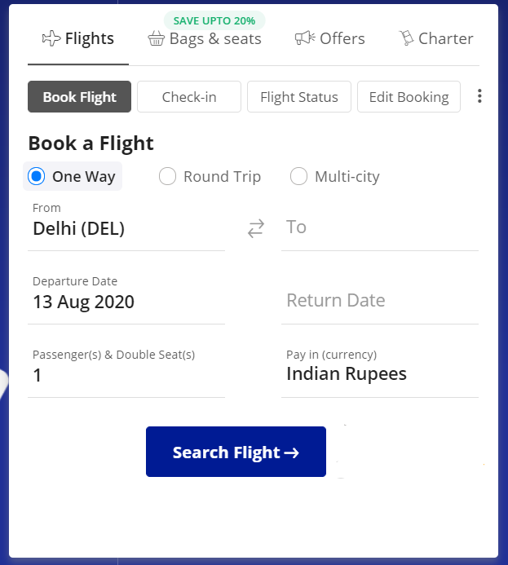

Flight Results Screen
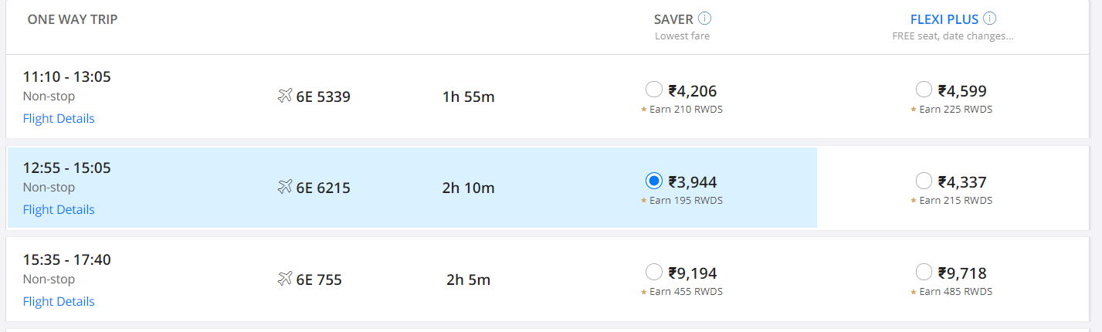

Flight Details screen

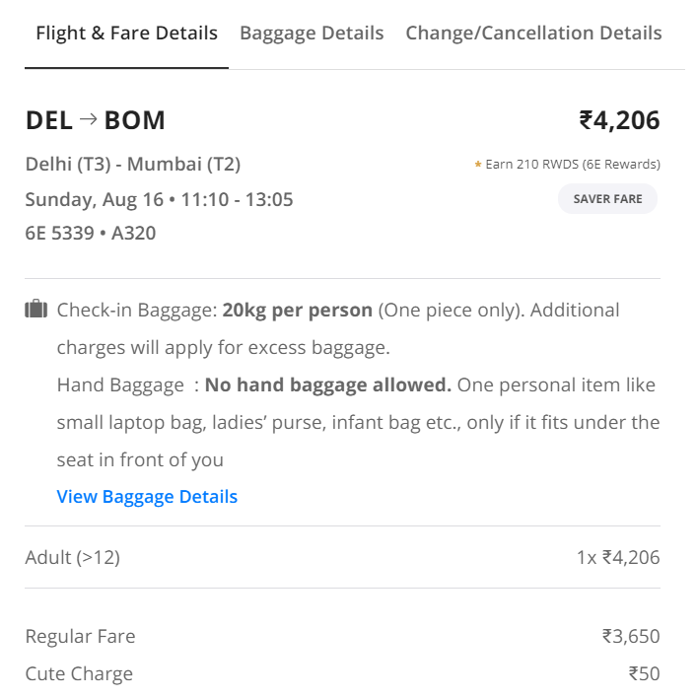

Appendices

List of Acronyms
[If needed, create a list of acronyms used throughout the BRD document to aid in comprehension.]

Glossary of Terms
[If needed, identify and define any terms that may be unfamiliar to readers, including terms that are unique to the organization, the technology to be employed, or the standards in use.]

Related Documents
[Provide a list of documents or web pages, including links, which are referenced in the BRD.]

